# Safety and Security

One must consider the many risks that come with new biometric technology. It could be said that not only does biometric technology add to the security and saftety risks, it can also solve some.

Once the biometric data goes digital and stored in a centralized database, it can be compromised. If a security breach occurred currently, new credits and details can be released to bank customers however a new fingerprint would not be possible to release. Banks must explore more secure methods of storage. Perhaps, standardization could solve this problem. Once governments have set standards, different companies will not be able to operate under different degrees of scrutiny providing security & safety for users.

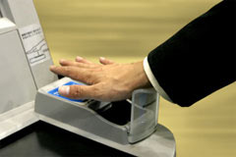

Biometric technology could combat many major security issues such as:

* Identity theft
* ATM fraud.

Identity theft in the form of enrollment fraud will be reduced. A fraud can currently apply for a credit card using a fake I.D. however it would be difficult for a fraud to apply using a fake fingerprint. Card trapping where a card is physically captured and compromised – frauds go on to create counterfeit cards. This will issue would be combatted if biometric touch was used at an ATM as shown in the image below.

